CSC 134 Spring 2021

Assignment 3

Specify the following queries based on the database schema shown in the following figure, using the operations of the relational algebra. The submission must be typed. Submit a PDF file to Canvas. You must answer the queries using relational algebra. Answer them in any other ways, such as SQL, will get a 0.
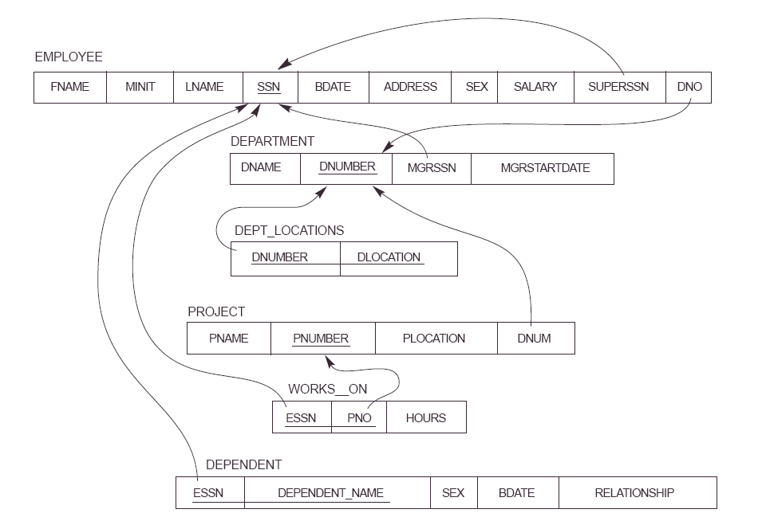

(1) Retrieve the names (fname,lname) of all employees who do not work on any project.

(2) Retrieve the names (fname,lname) of employees who work more than 9 hours per week on the 'ABC' project. (“ABC” is project name.)

(3) Retrieve the department (dname) that has a location in ‘Denver’.

(4) Find the names (fname,lname) of employees who are directly supervised by 'Steven Miller'.

